* **Project name - SportyShoes**

**Project Detail :**

Project Name: SportyShoes

Developer Detail :

**Neeti Kulkarni**

**GitHub repository link:**

[Neeti-Kulkarni/SportyShoes (github.com)](https://github.com/Neeti-Kulkarni/SportyShoes)

**Project Details:**

This Project is designed to follow the following details:

* The Shoe portal has 2 access sections. One for ***ADMIN*** & one for ***USER.***
* Only authorised admins can enter the website. Admin details are entered using *“POSTMAN”.*
* Admin can INSERT, EDIT, DELETE the SHOE details, also admin can see USER DETAILS.
* User has to signup first to enter the website. User Registration is done from the front end.
* Once the users with correct credentials can LOGIN.
* After logging in, USERS can see the shoe details with price, so that they can decide which one to buy.
* There are 2 dummy bank portals having some balance. BANK DETAILS are also inserted via *“POSTMAN”.*
* After deciding which shoe must be purchased, the user must be redirected to the bank portal.
* Then price should be compared with the user chosen bank id’s balance for successful transaction or declined transaction..

Technologies and tools Used:

* *Frameworks-* Spring Framework
* *Tools- Spring Boot*
* *ORM- Hibernate*
* *For Frontend-* Jsp, Html, Css
* *For Backend-* Java, Springboot, Hibernate, Restful(Postman), JPA
* *Database-* MYSQL workbench
* *IDE-* Eclipse

FLOW CHART*:*

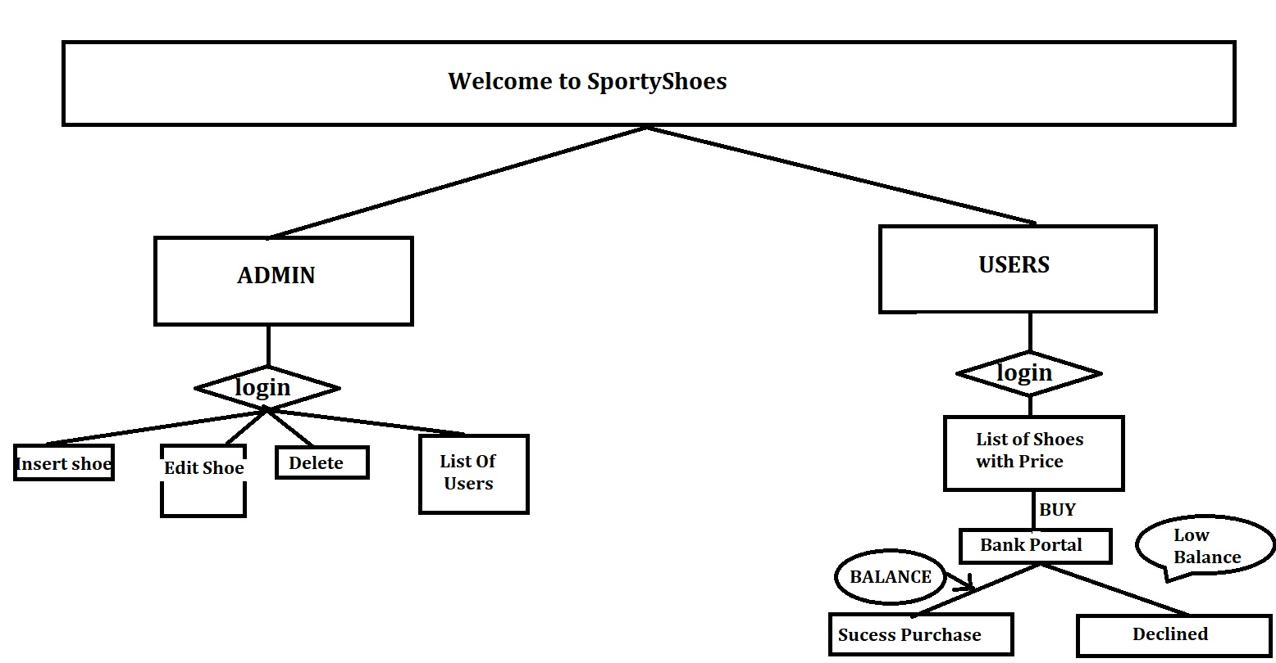

Sprints Planned:

